# The collapse of a keystone forage fish species

Buren, A.D.1§, Murphy, H.M.1*§, Adamack, A.T.1, Davoren, G. K.2, Koen-Alonso, M.1, Montevecchi W.A.3, Mowbray, F. K.1, Pepin, P.1, Regular, P.1, Robert, D.4, Rose, G.A.5, Stenson, G.1, Varkey, D.1

Affiliations:

1. Northwest Atlantic Fisheries Centre, Fisheries and Oceans Canada, St. John's, NL, Canada

2. Department of Biological Sciences, University of Manitoba, Winnipeg, MB, Canada

3. Cognitive and Behavioural Ecology Progamme, Departments of Biology and Psychology, Memorial University of Newfoundland, St. John’s, NL, Canada

4. Institut des sciences de la mer, Université du Québec à Rimouski, Rimouski, QC, Canada

5. Institute for the Oceans and Fisheries, UBC, Vancouver, BC, Canada.

*corresponding author: Tel: +1 709 772 4925; Fax: + 1 709 772 4138; e-mail: Hannah.Murphy@dfo-mpo.gc.ca

§ A.D.B and H.M.M. contributed equally to this paper and others have contributed equally. Authors have been listed in alphabetical order for each contribution level.

Running page head: Collapse of keystone forage fish

## Abstract

Capelin are a focal forage species of the Northwest Atlantic ecosystem as they act as an energy conduit from lower to higher trophic levels. According to acoustic monitoring surveys conducted by Canada and the former USSR, the Newfoundland capelin stock (NAFO Division 2J3KL) suffered an order of magnitude decline in biomass in 1990-91. This collapse was concomitant with drastic changes in the ecosystem during the late 1980s and early 1990s. However, while the results of more than a dozen studies have supported a capelin stock collapse, there is also literature suggesting that the capelin stock has not collapsed during that period. The non-collapse hypothesis purports that rather than collapsing in 1990-91, the capelin stock either (1) changed its migratory patterns while the timing of the acoustic survey remained constant, leading to a spatio-temporal mismatch between the survey and the stock, or (2) became less migratory and remained inshore year round, therefore being largely underestimated by the offshore acoustic surveys. We tested the collapse and non-collapse hypotheses using multiple independent datasets, which included both fishery-dependent (inshore commercial catch) and fishery-independent (spring and fall acoustic and fall bottom trawl surveys, oceanography cruises, capelin larval indices, aerial surveys, predator diet and behavior) data, and diverse statistical methods. The hypothesis of a non-collapse of the capelin stock was rejected by our analyses. The weight of evidence approach led us to conclude that the Newfoundland capelin stock suffered a population collapse in 1990-91 with minimal recovery over the subsequent 25 years.

Keywords: capelin, *Mallotus villosus*, acoustic survey, regime shift, Newfoundland

## Introduction

Forage fish play crucial roles in many ecosystems, transferring the bulk of the energy from lower trophic levels to large vertebrate predators. Typically, they are small shoaling species that are characterized by short life expectancy and rapid but variable growth driven by environmental factors. Forage fish species often exhibit ‘boom and bust’ population dynamics, i.e. their abundances change rapidly and substantially and undergo phases of extremely high and extremely low abundances (Soutar & Issacs 1969, Schwartzlose et al. 1999, Chavez et al. 2003, Pikitch et al. 2012, Pikitch et al. 2014). Forage fish species can experience prolonged periods of ‘bust’ dynamics. For example, the Norwegian spring-spawning Atlantic herring (*Clupea harengus*) stock collapsed in the late 1960s after a pulse of overfishing and remained at very low levels until the late 1980s (Toresen & Østvedt 2000, Dragesund et al. 2008, Skagseth et al. 2015); while sardine (*Sardinops sagax*) and anchovy (*Engraulis* spp.) have decade-scale regimes of high and low abundances where populations thrived for 20 to 30 years and then disappeared for similar periods (Schwartzlose et al. 1999, Chavez et al. 2003, Barange et al. 2009).

Capelin (*Mallotus villosus*) is the focal forage fish species in ecosystems of the North Atlantic Ocean (Templeman 1948, Jangaard 1974, Vilhjálmsson 1994, Carscadden et al. 2001). The three most important capelin populations in the North Atlantic are in the Barents Sea, off the coast of Iceland, and along the Newfoundland and Labrador (Canada) continental shelf. The Barents Sea capelin stock experienced four collapses over the past 4 decades: the mid- to late-1980s, the mid-1990s, the mid-2000s, and the mid-2010s. The size of the stock fluctuated between 3 and 7 million tonnes (Mt) during the ‘boom’ phase and around 200 thousand tonnes during the ‘bust’ phase. There is general agreement that bottom-up changes were the driving force behind these ‘boom-bust’ dynamics (Gjøsæter et al. 2009). The Icelandic capelin stock underwent similar dynamics, with three ‘bust’ phases over the past 4 decades: the early 1980s, the early 1990s, and most of the 2000s. The size of the stock was around 1.5-2 Mt during the ‘boom’ phase and between 100-500 thousand tonnes during ‘bust’ phase (ICES 2017). The first two ‘bust’ phases were due to a combination of poor recruitment and the stock being easily available to the fishing fleet, while the most recent ‘bust’ phase was likely associated with a climate-related shift in distribution (Pálsson et al. 2012, Carscadden et al. 2013).

Fisheries and Oceans Canada (DFO) is responsible for the assessment of the Newfoundland and Labrador (NL) capelin stock. DFO concluded that the stock experienced an order of magnitude decline in 1990 with minimal recovery during the past two decades (DFO 1994, Miller 1994, 1997, DFO 2008, 2010, 2013, 2015, 2018). The size of the stock fluctuated between 2-6 Mt from 1982 and 1990, and between 25-900 thousand tonnes during the ensuing period (DFO 2015). This decline was concomitant with drastic changes in the ecosystem during the late 1980s and early 1990s (deYoung & Rose 1993, Gomes et al. 1995, Montevecchi & Myers 1997, Lilly et al. 2000, Rice 2002, Koen-Alonso et al. 2010, Hammill et al. 2011, Pedersen et al. 2017), including major changes in the biology and ecology of capelin, such as delayed and protracted spawning, changes in their geographical and vertical distribution, and declines in somatic condition and size and age at maturity (Frank et al. 1996, Carscadden & Nakashima 1997, Carscadden et al. 2001, Mowbray 2002, Nakashima & Wheeler 2002, DFO 2010). The collapse of capelin is considered a key signal in the identification of the regime shift that occurred in the early 1990s. BIG JUMP IN LOGIC

The non-collapse hypothesis postulates that the capelin stock in 1990-91 did not collapse but that the offshore acoustic surveys have failed to detect large capelin aggregations since 1990 because of a spatio-temporal mismatch between the surveys and the stock (Frank et al. 2016). Specifically, the non-collapse hypothesis states that post-1990 either (1) capelin changed their migratory patterns while the timing of the acoustic survey remained constant, leading to a spatio-temporal mismatch between the survey and the stock or (2) capelin became non-migratory in 1990 and are therefore undetected by the offshore surveys. Support for the non-collapse hypothesis was based on changes in the biology of capelin post-1991 (e.g., distribution and demography), re-analysis of the offshore research surveys (multi-species bottom trawl and acoustic), and the response of various components of the ecosystem [e.g., zooplankton, Atlantic cod (*Gadus morhua*), seabirds, seals] to the large-scale changes that have occurred since the early 1990s (Frank et al. 2016). The objective of this paper is to assess the empirical support for the hypothesis of capelin stock collapse (DFO 2015) versus that of non-collapse (Frank et al. 2016) using all available data.

**Methods and Results**

To test the hypotheses of collapse and non-collapse of the capelin stock in NAFO Divisions 2J3KL (hereafter Div. 2J3KL; Fig. 1), we applied the weight of evidence approach using multiple, independent data sets and diverse statistical methods (e.g., triangulation, sensu Munafò & Davey Smith 2018). In some sections, new data and analyses were presented to test alternative hypotheses. Each section concludes by weighting evidence in support for each alternative hypothesis. Once this was completed for all sections, the weight of evidence approach was used to determine which hypothesis was best supported by the combination of previously-published results and additional analyses based on independent data sets.

## Capelin

### Offshore capelin distribution: acoustic surveys NO MENTION OF SPRING SURVEYS – SEE HO TO FIT THEM IN

The capelin collapse hypothesis is supported by the fall and spring offshore acoustic surveys conducted by Canada and the former USSR that found a sudden decrease in capelin biomass in the fall of 1990 in Div. 2J3KL (e.g., Miller & Lilly 1991, Bakanev 1992, Miller 1992, 1993, 1994, Mowbray 2014). The non-collapse hypothesis purports that Canada and the USSR offshore acoustic surveys found low capelin biomasses in the fall of 1991 and 1992 in Div. 2J3KL because capelin did not migrate offshore starting in the fall of 1990 (Frank et al. 2016).

From 1982 to 1992, Canada conducted fall (October) acoustic surveys for capelin in Div. 2J3K (Fig. 1) (e.g., Miller and Carscadden 1984, Miller and Lilly 1991). The fall acoustic surveys targeted the maturing portion of the stock during winter feeding migrations to provide estimates of the size and number of maturing fish being recruited to the fishery the following year (Mowbray 2014). The capelin stock in Div. 2J3K was also acoustically surveyed by the former USSR in November from 1982-1992 (Bakanev 1992; Fig. 1). The USSR fall acoustic surveys were conducted approximately a month later than the Canadian surveys and consistently estimated higher capelin abundances, which may have been due to timing, as capelin start aggregating into large overwintering shoals in November (Winters 1995). In 1990, the Canadian fall acoustic survey reported a very low capelin biomass (96 thousand tonnes, < 5% of the biomass surveyed in 1989) while the USSR acoustic survey reported the smallest biomass since 1984 (631 thousand tonnes) (Winters 1995). Both the USSR and Canadian acoustic surveys reported record low capelin biomass in the fall of 1991 and 1992 (16-55 thousand tonnes) (Winters 1995). The decrease in capelin biomass in both surveys corresponded with very few capelin being detected off the coast of Labrador and a southward shift in stock distribution to the southern portion of Div. 3K and northern portion of Div. 3L (Miller & Lilly 1991, Miller 1992). A Canadian expanded fall survey (Div. 2J3KL) in 1993-94 was conducted to determine if the ‘missing’ capelin could be located. However, the expanded fall acoustic survey confirmed the findings of the 1991-92 fall surveys that offshore capelin biomass was low and characterized by a southward change in distribution (Miller 1994, 1995). This is consistent with the sprnig acoustic survey… Post-1991, capelin is only acoustically surveyed in the spring in Div. 3L by Canada (1996, 1999-2005, 2007-2015, 2017-18) with the discontinuation of the other three acoustic surveys in the early 1990s (Canada fall acoustic survey in 1994; USSR fall and spring acoustic surveys in 1992 and 1994, respectively).

While the offshore acoustic surveys provided strong evidence of a capelin collapse, they did not survey the inshore area. The non-collapse hypothesis uses unquantified densities of overwintering maturing capelin and large schools of immature capelin observed during winter surveys conducted in Trinity Bay in 1967-68 (Winters 1970) as evidence that significant densities of capelin can inhabit the inshore year-round. DFO tested the hypothesis of year-round residency of capelin in the inshore by conducting seasonal acoustic surveys in Trinity Bay (September and October 2003; January, June and September 2004-05) and expanding the annual offshore spring acoustic survey into Trinity Bay (1999-2005, 2007-13, 2017) (Fig. 1; see supplementary section for details on methods). Seasonally, capelin densities were low in Trinity Bay in January and May, and the maximum mean density of capelin was observed in June (10,000 kg km-2), which corresponded with the start of the spawning period when capelin were highly aggregated inshore (Fig. 2 a). In September and October, capelin densities were low once again (Fig. 2 a). There was also a distinct seasonal pattern in the age and maturity composition inshore. In January, overwintering fish were composed of ~70% immature age-1 and age-2 fish (Fig. 2 b, c); the relative contribution of older fish increased through the spring as maturing age-2 and age-3 fish migrated into Trinity Bay (Fig. 2 b, c); and by October, immature age-1 fish dominated the inshore area, strongly suggesting that spent mature fish either died or left the Bay (Fig. 2 b). In agreement with this finding, an inshore acoustic survey in January 2000 for overwintering cod from Conception Bay to Notre Dame Bay found concentrations of juvenile capelin (O'Driscoll & Rose 2001) but few older fish (G.A. Rose, unpublished data). The seasonal surveys found no evidence of a large inshore, non-migratory capelin stock.

We also tested the capelin non-collapse hypothesis by investigating the spatial distribution of capelin in years when the annual offshore May acoustic survey included an inshore component (1999-2005, 2007-13, 2017). Capelin biomass inshore and offshore in May was weakly negatively correlated but non-significant (Pearson Correlation: t = -0.83, df = 14, p= 0.42, R = -0.22). In the majority of years, > 90% of surveyed capelin biomass was offshore (Fig. 3). In four of the 14 years (2000, 2001, 2005, and 2010), 27 - 42% of the total capelin biomass surveyed was inshore (Fig. 3). A significant portion of the capelin population inshore in some years provides support for the non-collapse hypothesis. However, simple back-of-the-envelope calculations indicate that it is unrealistic to assume that the 3 to 6 Mt of capelin that are ‘missing’ in the offshore surveys since 1990 are now residing in the inshore. The minimum density for 3 to 6 Mt of capelin undetected in up to ~71,000 km2 of un-surveyed inshore waters would have to be between ~41,000 to ~170,000 kg km-2, uniformly distributed throughout the un-surveyed area. The maximum mean density of capelin observed in the Trinity Bay seasonal acoustic survey was 10,000 kg km-2 in June, and the maximum mean density of capelin inshore outside of the spawning period, including the inshore May acoustic survey, was only 120 kg km-2 (Fig. 2 a). Overall, these analyses indicate it is unlikely that the capelin stock became non-migratory and has remained inshore since 1990.

In summary, while the fall and spring acoustic surveys in Div. 2J3KLNO support the collapse of the capelin stock, they cannot refute the hypothesis that capelin are non-migratory post-1990 as inshore areas were not systematically surveyed. However, the lack of significant inshore aggregations of capelin outside of the peak spawning period during seasonal and annual spring acoustic surveys, and the impossibility of the ‘missing’ 3-6 Mt of capelin (up to 170,000 kg km-2, uniformly distributed throughout the un-surveyed area) remaining undetected in the inshore strata since 1990 by DFO and hundreds of fishing vessels equipped with echosounders on the water provide strong support for the capelin collapse hypothesis.

**Offshore capelin distribution: annual multi-species bottom-trawl surveys**

The non-collapse hypothesis used the fall bottom trawl survey (FBTS) data to point to a westerly, inshore shift in the center of capelin concentration in 1996-2010 compared to 1985-1995 (Frank et al. 2016). However, the center of concentration of capelin using the FBTS presence/absence data from 1985-1995 found inshore distributions occurred in three high abundance years (1986-1988, Fig S2 in Frank et al. 2016). This variability is likely related to the poor catchability of capelin in the Engel otter trawl (used from 1978-1994), which was designed for harvesting commercial groundfish like flatfish and Atlantic cod. In 1995, the gear used for sampling in the FBTS was changed to a Campelen 1800 shrimp trawl, which improved the catchability of capelin in the survey. A similar center of gravity analysis using only post-1995 FBTS data showed a southerly shift in capelin distribution with a recent shift to the northwest in 2011-14 (DFO 2015). However, neither of these analyses accounted for inter-annual changes in capelin spatial distribution due to FBTS sampling effort nor considered the uncertainty around the center of gravity estimates.

To address the abovementioned issues and to test the non-collapse hypothesis of a shoreward shift in capelin distribution post-1991, we revisited the center of gravity analysis of the FBTS data using the approach described in Thorson et al. (2016). We used the VAST package in R (Thorson & Barnett 2017) to fit a geostatistical delta-generalized linear mixed model to estimate the spatial and temporal distribution of capelin (Thorson et al. 2016). The advantages of this approach are that it accounts for inter-annual changes in the spatial distribution of sampling effort and offers a means of estimating the standard error of the center of gravity metric, which provides perspective on the significance of distributional shifts. Like DFO (2015), we focused on the post-1995 period so that the data considered in our analysis was collected using only one gear type with a consistent catchability of capelin (i.e. Campelen 1800 shrimp trawl). Our geostatistical analysis does not support the hypothesis that capelin shifted their distribution towards the inshore post-1995 and there is no evidence of an easterly or westerly movement in the center of gravity of capelin (Fig. 4). Instead, the center of gravity of capelin remains > 100 km offshore and demonstrates pronounced shifts in the north-south axis (Fig. 4). Like the acoustic surveys, the FBTS has poor survey coverage of the inshore. It is, therefore, possible that significant aggregations of capelin could go undetected. However, if significant capelin aggregations were present inshore, then the center of gravity would be oriented towards the inshore during years when more inshore strata were surveyed (1996-1998, 2000-2002, 2004-2006, 2010, 2013), which it is not (Fig. 4).

There has been a bias for increased catches of capelin in the FBTS post-1995 not only due to a change in sampling gear but also due to the increased proportion of capelin biomass in the trawl zone (bottom 4 m of the water column) post-1991 (Mowbray 2002), likely in response to a decline in the risk of groundfish (e.g., Atlantic cod) predation that may drive capelin into the pelagic zone (Rose 1993, McQuinn 2009). Furthermore, when capelin densities are low, capelin are found in closer association with the bottom and diel vertical migration is less pronounced compared to when capelin densities are high (Mowbray 2002). Due to the inherent biases in the FBTS data, we also considered other data sources to investigate the center of distribution of capelin post-1991 (sensu Jech & McQuinn 2016). Juvenile capelin surveys using an International Young Gadoid Pelagic Trawl (IYGPT) in the northeastern bays and the offshore from 1994-99 found centers of distribution of capelin juveniles on the northern Grand Banks and along the northeast coast, but not in the bays, of Newfoundland (Anderson et al. 2002) which is consistent with capelin migrating to their nursery areas in the offshore. This independent study of juvenile capelin distribution supports our center of gravity analysis using the FBTS data.

In summary, capelin distribution moved in the north-south rather than east-west axis post-1995 based on a center of gravity of analysis that accounts for both the inter-annual changes in the spatial distribution of sampling effort and the uncertainty around the center of gravity estimates. The center of gravity analysis does not support the hypothesis of an inshore movement of capelin post-1995, and, in combination with our analysis that up to 170,000 kg km-2 of capelin uniformly distributed throughout the un-surveyed inshore waters is required to make up for the ‘missing’ 3-6 Mt of capelin since 1990, supports the capelin collapse hypothesis.

### Residence time of capelin concentrations during offshore acoustic surveys in Div. 3L

The capelin non-collapse hypothesis purports that the delay in the timing of capelin spawning post-1991 led to a mismatch in capelin availability to the spring acoustic survey, which has resulted in the spring acoustic survey severely underestimating capelin biomass offshore (Frank et al. 2016). Since 1991, capelin spawning has been persistently delayed on average by four weeks (DFO 2018). Meanwhile, the spring acoustic survey has been fixed spatially and temporally since the 1980s, implying changes in how the spring acoustic survey perceives migrating capelin post-1991. However, it is important to note that the spring acoustic survey, which encompasses a capelin nursery area, was primarily designed to survey the non-migratory, immature portion of the stock, rather than the spawning migration (Mowbray 2014). All age classes acoustically surveyed are included in the annual index of capelin abundance, but the spring acoustic survey does not target capelin spawning migrations, and, therefore, has never been designed to derive a proxy for spawning stock biomass.

While the delay in spawning time should not have a direct effect on the overall acoustic abundance index derived from the spring acoustic survey, the earlier observed maturation of capelin post-1991 could have an effect on the population fractions sampled by the spring acoustic survey. The age-2 portion of the stock is the main component being surveyed and the proportion of maturing age-2 capelin has increased since 1991 (4% pre-1991 compared to 37-79% post-1991) (Mowbray 2014, DFO 2018). Earlier maturation could alter the internal structure of the stock with inter-annual variability in the proportion of age-2s starting their adult migration patterns and would, therefore, be unavailable to the survey. However, there has been high internal consistency in the spring acoustic survey, with the index of abundance for the age-3 cohort being strongly correlated with the index of abundance for the age-2 cohort from the previous year (DFO 2018), which implies that the spring acoustic survey can meaningfully capture relative changes in the overall stock, regardless of migrating/non-migrating fractions.

If there was a significant inshore capelin population post-1991, we would expect to see this change in population demographics reflected in both the offshore acoustic survey and the inshore commercial catch. For the inshore commercial fishery pre-1991, mature age-2 capelin was a negligible component of the fishery (< 5% of total catch) (DFO 2018). Post-1991, the contribution of mature age-2 capelin increased to almost half of commercial inshore catches (DFO 2018), which supports the hypothesis of inshore residence and early maturation of capelin proposed by Frank et al. (2016). However, the population demographics from catches offshore refute the non-migratory hypothesis as the proportion of age-2 and age-3 fish sampled offshore has remained constant pre- to post-1991 at ~60% and ~28% of the catch, respectively (DFO 2018). Furthermore, the increased proportion of mature age-2 fish in the inshore catch post-1991 can be explained by the increase in proportion of age-2 fish maturing offshore and undergoing a spawning migration, rather than an absence of migration per se.

In summary, neither the persistent delay in spawning time nor earlier maturation age of capelin post-1991 seem to significantly affect the ability of the spring acoustic survey to provide a relative index of capelin abundance. Data from the spring acoustic survey supports the capelin collapse hypothesis.

### Independent indices of inshore capelin abundance

The non-collapse hypothesis implied that strong correlations among independent inshore indices of capelin abundance post-1991 in addition to observed minimal changes in these indices between the late 1980s and the early 1990s was supportive of a stable stock (Carscadden & Nakashima 1997, Frank et al. 2016).

Two inshore indices collected by DFO during the 1980s and 1990s were an aerial abundance index and inshore commercial catch rates. The aerial survey was designed to estimate capelin spawning stock biomass based on the area of capelin schools near spawning beaches in Div. 3L (Nakashima 1997). The aerial survey commenced in 1982, and initially followed four defined survey tracks in Conception and Trinity Bays during a fixed period of mid-June to early July (Carscadden et al. 1994). Protracted spawning post-1991 violated a key assumption of the aerial surveys: all schools must arrive at the same time in each bay to form a single spawning peak. Protracted spawning from early July to mid-August in 1991-93 resulted in multimodal capelin spawning peaks that were covered with variable success by the aerial survey (Nakashima 1996). For example, in 1993, the peak spawning period was adequately surveyed in Conception Bay, but two spawning peaks in Trinity Bay, based on the egg deposition index, were missed (Nakashima 1996). In 1996, aerial coverage was at its lowest since 1991 due to poor weather and technical problems (Nakashima 1997). In 1997, the geographical coverage of the aerial survey was reduced to two transects in the inner areas of Trinity and Conception Bays (Anon 1998). While the estimated aerial abundance index in 1997 was fourth highest in the series, there were concerns that the limited geographical coverage of the aerial survey did not accurately reflect the status of the stock (Anon 1998). Six of the eight years of aerial data post-1991 did not adequately cover peak spawning times (1991-93), had poor weather and technical difficulties (1996), and had reduced geographical coverage (1997-98). The aerial survey was discontinued in 1999.

The inshore commercial catch rate data have not been included in the capelin stock assessment process since 1993 due to changes in management regulations post-1991. As a consequence of the small sizes of spawning capelin post-1991, management regulations introduced a size criterion of 50 capelin/kg to reduce dumping of undersized capelin (Carscadden & Nakashima 1997). This size criterion effectively closed the fishery in 1994 and 1995. From 1996, the size criterion was removed but management regulations to reduce discarding of small, unmarketable capelin resulted in fishing effort being concentrated to a few days when capelin were highly available (Anon 1998). Post-1991, the inter-annual variability in participation in the fishery due to fish quality and market forces resulted in overall fishing effort being reduced and concentrated to when capelin were highly available resulting in high catch rates which rendered the inshore catch rate index useless as an indicator of stock abundance (Anon 1998).

In summary, due to changes in capelin biology and management measures post-1991, neither of the inshore indices provide reliable data on spawning stock biomass. These indices cannot be used to support or refute either hypothesis.

### Inshore recruitment index

Capelin larval production in Trinity Bay in August did not decrease appreciably post-1991, which was used as support for the non-collapse hypothesis (Frank et al. 2016). DFO collects two larval indices in Trinity Bay: an emergent larval index (3-10 mm SL) in a nearshore area and a late-larval index (10-30 mm SL) (see Nakashima & Mowbray 2014 for more details). Given the persistently late capelin spawning since 1991, it is appropriate to compare late-larval densities in August in years pre-1991 and September in years post-1991(Nakashima & Mowbray 2014). Late-larval densities during the 2000s were consistently lower and more variable than during the 1980s: average late-larval density in Trinity Bay in September 2002-15 was 30.9 m-2 (SD: 26.9, range 6.73-96.95 m-2) while in August 1982-86 was 48.8 m-2 (SD: 15.1, range 33.2-73.6 m-2). In 12 of the 14 years in the 2000s, average late-larval densities in September were below the average August larval densities in the 1980s. The decrease in larval productivity post-1991 provides equivocal support for the capelin collapse hypothesis.

Post-1991, the emergent larval index (2001-2015) was related to the age-2 abundance index from the spring acoustic survey, which was lagged by 2 years in order to compare survival in the same cohort (Murphy et al. 2018). The positive, significant relationship between two fishery-independent inshore and offshore indices post-1991 supports previous research that identified early larval survival as an important driver of capelin recruitment (Frank & Leggett 1982, Leggett et al. 1984, Dalley et al. 2002). This result suggests that the offshore acoustic survey tracks inshore larval productivity, supporting the capelin collapse hypothesis. While it is possible that the offshore age-2 capelin abundance index reflects an overflow or spillover of age-2 capelin in proportion to inshore productivity, the inshore acoustic seasonal surveys did not find a significant inshore population of capelin outside of the spawning period.

In summary, the significant relationship between two fishery-independent inshore and offshore indices post-1991 concurs with the collapse hypothesis.

### Ecosystem response

### Temporal dynamics of cod weight-at-age and condition

From the early 1980s to the late 1990s, Atlantic (also known as Northern) cod’s condition and weight-at-age declined markedly in the northern portion of its range (Div. 2J) with similar declining trends in Div. 3K, while condition indices remained relatively unchanged in the southern portion of Atlantic cod’s range (Div. 3L). Furthermore, weight-at-age of 4- and 5-year old Atlantic cod saw a small increase in the mid-1990s in Div. 3L that later subsided. This ephemeral increase in weight-at-age in Div. 3L during the mid-1990s was considered as support for the non-collapse hypothesis (Frank et al. 2016).

The existence of spatial structure in condition traits of Atlantic cod has been documented extensively in the scientific literature (Lilly et al. 2005, Neville et al. 2018, Rose & Rowe 2018), with historical latitudinal gradients in growth (length-at-age) and condition indices (liver, gutted and total body mass) (Buren et al. 2014b, Morgan et al. 2017). Atlantic cod weight-at-age and liver condition indices have never been spatially homogenous due to the species complex inhabiting distinct ecosystem production units in Div. 2J3KLNO (e.g., Lilly 2005, Koen-Alonso et al. 2013, Morgan et al. 2017). These units are characterized by distinct marine communities and food web systems (Pepin et al. 2010, Pepin et al. 2012, Koen-Alonso et al. 2013, NAFO 2014, Pepin et al. 2014). Therefore, the non-homogenous traits of Atlantic cod from Labrador (Div. 2J) to the southern Grand Banks (Div. 3NO) are typical of this stock complex and cannot be used to support the non-collapse hypothesis.

Changes in spatial overlap between the collapsed stocks of Atlantic cod and capelin post-1991 may have exacerbated the spatial differences in Atlantic cod condition indices (Rose et al. 2000). Historically, Atlantic cod was a dominant fish predator on the NL Shelf, with capelin being its primary prey (Winters & Carscadden 1978, Lilly 1987, Lilly 1991). During and post-1991, capelin shifted its fall distribution from having two distinct aggregations, one in the northwest (Div. 2J3K) and one in the southeast (Div. 3L, at the northern slope of the Grand Banks) to having only one in the southeast (Lilly & Davis 1993, Miller 1994).. Coincidently, Atlantic cod moved southward on the northeast Newfoundland Shelf in the late 1980s and early 1990s and aggregated within a small area on the northern Grand Banks and in the Bonavista Corridor (Rose 1993, Rose et al. 2000). These authors hypothesized that the observed shift in Atlantic cod distribution is because they moved in response to the southerly distribution of capelin post-1991 (Rose et al. 2000). Atlantic cod’s weight-at-age and liver condition worsened in northerly areas where there was no spatial overlap between Atlantic cod and capelin, and remained relatively stable in southerly areas, where the collapsed Atlantic cod stock overlapped with capelin.

In summary, the spatial structure of Atlantic cod condition indices is explained by the distinct ecosystem production units the Northern stock complex inhabits. Since 1991, Atlantic cod condition worsened in northerly areas where there was no spatial overlap with capelin, and remained relatively stable in southerly areas where the collapsed Atlantic cod stock overlapped with the capelin stock. The observed change in Atlantic cod distribution and condition indices post-1991 concur with the capelin collapse hypothesis.

**Harp seal population trends and diet**

Large numbers of starving harp seals were observed following the collapse of capelin in the Barents Sea in the mid-1980s (Haug & Nilssen 1995). The absence of an obvious response in Northwest Atlantic harp seals (*Pagophilus groenlandicus*) to the collapse of the capelin stock in 1991 was considered support for the non-collapse hypothesis (Frank et al. 2016). However, there are significant differences between the two regions. In the Barents Sea, the collapse of capelin during the mid-1980s occurred when the stocks of other energy rich forage fish, including Atlantic herring and Arctic cod (*Boreogadus saida*), were severely depleted (Hamre 1994, Hop & Gjøsæter 2013). Therefore, the effects of the capelin collapse were amplified and reached several taxa including seals, seabirds and Atlantic cod (Hamre 1994). Barents Sea capelin declined in 1992-93 without a similar ‘invasion’ of starving seals. This was likely due to the availability of alternative prey (Atlantic herring and polar cod, Nilssen et al. 1998). In the Northwest Atlantic, alternate prey were still available during the early 1990s (Lilly et al. 1994, Bourne et al. 2015) as reflected in Arctic cod and Atlantic herring being the dominant prey items in harp seal diet in the early 1990s (Stenson 2012).

While Northwest Atlantic harp seals did not show catastrophic mortalities post-1991, they have been impacted by the decline in capelin. Until the late 1970s, pregnancy rates were consistently around 85%. Since then, pregnancy rates have been highly variable (ranging from ~20% to 75%) with an overall declining trend (Stenson et al. 2014, Stenson et al. 2016). In addition, late-term abortions have become a regular occurrence since the late 1980s (Stenson et al. 2016). Stenson et al. (2016) found that while the general decline in harp seal fecundity reflected density-dependent processes associated with increased population size, including the late-term abortion rates in their model allowed them to explain the large inter-annual variability in pregnancy rates. Changes in the abortion rates, in turn, were found to be influenced by ice cover in late January and capelin biomass. Buren et al. (2014a) showed that capelin abundance is associated with ice conditions, suggesting that late January ice conditions reflect changes in environmental conditions that influence many prey species. While higher catches in the Canadian commercial seal hunt from 1996-2008 contributed to reductions in the rate of harp seal population growth, lower pregnancy rates also had a major impact on the dynamics of this population. This is evident in the past decade where the commercial catches have declined but there has not been a concomitant increase in harp seal population abundance.

In summary, we cannot conclude that the absence of starving seals post-1991 indicates that capelin biomass remained stable and did not collapse. However, a declining trend in pregnancy rates and an increase in late-term abortions, which was related to capelin abundance, suggest capelin abundance has been a limiting factor in harp seals fecundity during the past three decades.

### Seabird population trends and diets

Populations of common murres (*Uria aalge*), Atlantic puffins (*Fratercula arctica*) and northern gannets (*Morus bassanus*) off eastern Newfoundland increased in the 1990s (Chardine et al. 2003, Chardine et al. 2013, Wilhelm et al. 2015) . Given that capelin is an important prey item for these predators, particularly during the breeding season, increases in their populations are inconsistent with a collapse in the capelin stock (Frank et al. 2016). Throughout the 1990s, common murres on Funk Island almost exclusively fed capelin to their chicks during the breeding season (Davoren & Montevecchi 2003). However, consistently high abundances of capelin at annually persistent spawning sites within seabird foraging ranges allowed for the high percentage of capelin in parental deliveries (Davoren et al. 2012, Davoren 2013). Fish stocks in general and pelagic stocks in particular contract their geographic range during periods of rapid population decline (Winters & Wheeler 1985, Worm & Tittensor 2011, Burgess et al. 2017). This pattern has been described for several finfish and shellfish populations (Prince et al. 2008, Wilberg et al. 2009), including Atlantic cod (Rose & Kulka 1999) and Northwest Atlantic herring stocks (Winters & Wheeler 1985). Capelin’s center of distribution moved southward during the early 1990s, i.e. closer to the vicinity of seabird colonies along Newfoundland’s northeast coast. Furthermore, common murres exhibited a temporal shift towards later breeding in the late 1990s, which corresponded with the later inshore arrivals of capelin in the common murres’ foraging range (Davoren & Montevecchi 2003). A higher proportion of capelin in common murre’s diet is not inconsistent with the collapse hypothesis, whereby the range of the collapsed capelin stock overlapped with the foraging range of breeding colonies of common murres, Atlantic puffins, and northern gannets.

Capelin also represented significant proportions of northern gannet’s diet from 1990-2012 (20 – 100 %) in contrast to pre-1990 (<12%, Montevecchi 2007, Bennett et al. 2013). This change in northern gannet diet was proposed as support for the non-collapse hypothesis (Frank et al. 2016). However, this change in diet was due to the cold water intrusion that occurred during the 1990s which precluded northern gannet’s preferred large pelagic warm-water prey (mackerel *Scomber scombrus*, Atlantic saury *Scomberesox saurus* and short-finned squid *Illex illecebrosus*) from moving into the region (Montevecchi & Myers 1997, Montevecchi 2007). For example, when mackerel and saury moved into the region in 2005 and 2006, the percentage of capelin in the gannets’ prey landings fell to 13% and 2%, respectively (Montevecchi 2007). As well, capelin was a minor prey item in seabird diets during the 1990s in Labrador (Bryant & Jones 1999, Baillie & Jones 2004), consistent with the hypothesis of a collapsed capelin stock, hyper-aggregated in the southern portion of its range.

The population increase of common murres post-1991 was associated with major reductions in adult mortality due to the coincident closure of the Atlantic salmon (*Salmo salar*) and Atlantic cod gillnet fisheries. The removal of thousands of gillnets from inshore areas during the 1990s and 2000s resulted in a significant reduction in bycatch mortality of breeding adult diving seabirds (Regular et al. 2013). Other reductions in common murre adult mortality associated with ship-sourced oil pollution and hunting also decreased during this same period (Wilhelm et al. 2009). The cumulative effects of these reductions in common murre adult mortality may have been more important for survival than negative population effects associated with bottom-up prey base reductions. Increases in the populations of Atlantic puffins and northern gannets in the 1990s and 2000s were associated with the same cumulative effects.

In summary, the trends in seabird abundance do not provide support for either the collapse or non-collapse hypothesis as other variables, such as removal of gill nets in the inshore area, had a larger impact on breeding adult seabird survival. Seabird dietary information does not provide support for either hypothesis, but seabird diet did reflect the late inshore arrival of capelin post-1991 (Davoren & Montevecchi 2003, Gulka et al. 2017) and was consistent with a collapsed, hyper-aggregated capelin stock.

### Zooplankton response: *Calanus finmarchicus* abundance

Given the magnitude of the capelin collapse, a significant increase in their main copepod prey, *Calanus finmarchicus*, might have been expected(Frank et al. 2016). To test this hypothesis, the continuous plankton recorder (CPR) data were used to estimate *C. finmarchicus* densities pre- and post-1991 in the NL region (Frank et al. 2016). No significant difference in *C. finmarchicus* densities pre- and post-1991 was found. However, the usefulness of CPR data for the Northwest Atlantic has been questioned. (Head & Pepin 2010) noted that only two years between 1960-1978 had more than 8 months of observations over the Grand Banks sections of the CPR sampling, which was the section used to test the collapse hypothesis (Frank et al. 2016), and inconsistencies in the course of the survey tracks from ships-of-opportunity resulted in uneven sampling of different water masses (Pepin et al. 2011). Furthermore, there was a substantial reduction in CPR mileage towed in the 1980s with a contraction of monitoring to 20° W in the eastern Atlantic (Reid et al. 2003). During this decade, monitoring science fell out of favor (Reid et al. 2003). Other researchers have assessed the CPR data as a potential data source for historical productivity in the NL region, but the large CPR data gap in the region from 1979-1990 precluded its use in a recent capelin study (Mullowney et al. 2016).

Since 1999, DFO has run the Atlantic Zonal Monitoring Program (AZMP) in three regions in eastern Canada: Scotian Shelf, Gulf of St. Lawrence, and NL. The AZMP program collects physical, chemical and biological data at stations along 14 oceanographic transects during offshore spring and fall cruises. While the AZMP data cannot be used to directly support or reject the hypothesis of a capelin stock collapse due to its commencement in the late 1990s, the AZMP data has been used to support the hypothesis that bottom-up processes are driving capelin survival in the NL region (Buren et al. 2014a, Obradovich et al. 2014, Murphy et al. 2018).

**Physical variability**

The non-collapse hypothesis used an analysis of ocean climate to show a change in environmental conditions ~ 5 years after the proposed capelin collapse and concluded that the physical evidence was weak for an environmental driver of capelin collapse (Frank et al. 2016). The authors contend that the transition from cold to warm conditions in 1996 is the distinguishing signal of their PC1 analysis (Frank et al. 2016). Elsewhere in the literature, 1991, not 1996, has been identified as climatologically important decadal signal due to its strong cold anomaly (e.g., Drinkwater 1996, Colbourne et al. 2014, Colbourne et al. 2015, Colbourne et al. 2016) and biologically important due to the dramatic regime shift in the North Atlantic ecosystem in the early 1990s with the collapse of Atlantic cod, capelin and other finfish species and correspondent increase in shellfish biomass (Gomes et al. 1995, Lilly et al. 2000, Rice 2002, Koen-Alonso et al. 2010, Hammill et al. 2011, Buren et al. 2014a, Pedersen et al. 2017); seabird dietary shifts from warm- to cold-water pelagic prey (Montevecchi & Myers 1992, Montevecchi & Myers 1997, Montevecchi 2007); and shifts in groundfish diet (Dawe et al. 2012).

In summary, based on the published literature and our analyses here, the weight of evidence approach suggests that cold environmental conditions were an important driver of the regime shift observed in the Northwest Atlantic in the late 1980s and early 1990s, and the cold-water anomaly of the early 1990s emerges as a likely critical tipping point in triggering the capelin collapse.

## Discussion

The weight of evidence led us to conclude that the Div. 2J3KL capelin stock suffered a bottom-up, climate-driven population collapse in 1990-91 with minimal recovery in the subsequent 25+ years. We found strong internal and external consistency in trends across multiple independent sources of data. In particular, the spring acoustic survey effectively tracked capelin year classes and was strongly correlated to an independent inshore larval abundance survey. Moreover, we found strong agreement across independent acoustic surveys conducted in offshore waters. These acoustic surveys supported the scenario of a capelin stock collapse in the early 1990s, and subsequent surveys and data examined were not consistent with the possibility that millions of tonnes of capelin have been residing along the northeast coast of NL for almost three decades. Our conclusion is thus consistent with that of numerous past studies that concluded that the NL capelin stock suffered an order of magnitude decline in the early 1990s (DFO 1994, Miller 1994, Rose & O'Driscoll 2002, Davoren & Montevecchi 2003, Rose 2007, DFO 2008, 2010, Mowbray 2012, DFO 2013, Buren et al. 2014a, Mullowney & Rose 2014, DFO 2015, 2018, Murphy et al. 2018).

In contrast, Frank et al. (2016) postulated that the capelin stock did not suffer a collapse but instead experienced a dramatic change in phenology post-1991, which dramatically reduced their vulnerability to existing surveys. They provided two alternative explanations for their non-collapse hypothesis: (1) a spatio-temporal mismatch between the spring acoustic survey and capelin phenology; and (2) a change in the ecology of capelin from a highly migratory stock to one that resides year-round within poorly-surveyed inshore waters. The first hypothesis was rejected both by Frank et al. (2016) and our analyses. From our test of the second hypothesis proposing the inshore residence of 3-6 Mt of capelin, we concluded that there would have to be a minimum average capelin biomass of 41,000 kg km-2 evenly distributed throughout the un-surveyed inshore area over much of the past 25 years to compensate for the ‘missing’ offshore fish. Instead, seasonal inshore acoustic surveys in Trinity Bay revealed a maximum capelin biomass of 10,000 kg km-2 in June, and much lower densities outside of the peak spawning period. Most importantly, we conclude it is not plausible that 3-6 Mt of capelin distributed inshore would have gone unnoticed for more than 25 years by both by DFO and the hundreds of harvesters based in the numerous fishing communities that span the northeast coast of NL.

The importance of capelin on ecosystem dynamics in NL is well documented (e.g., Templeman 1948, Carscadden et al. 2001, Rose & O'Driscoll 2002, Buren et al. 2014a). However, capelin are part of a complex food web in which the role of alternate forage species, including Atlantic herring, northern shrimp (*Pandalus borealis*), sandlance (*Ammodytes* spp.), Arctic cod, myctophids and euphasiids, cannot be ignored. After the collapse of the capelin stock in 1990-91, alternative forage fish species were available for higher trophic level consumption in the NL region (Lilly et al. 1994, Bourne et al. 2015) DFO 2017). This was evident in the different responses of harp seal populations to the collapse of capelin stocks in the Barents Sea in the 1980s and NL in the 1990s (Hamre 1994, Hop & Gjøsæter 2013, Stenson et al. 2016). The response of a predator to the collapse of one of its main prey species needs to be considered within the broader ecosystem context.

**Acknowledgements**

We acknowledgement the constructive comments of E. J. Pedersen, as well as anonymous reviewers. None of the authors have a conflict of interest to declare.

## Figure captions

Fig. 1. Capelin stock area in NAFO Divisions 2J3KL including the embayments of Newfoundland, Canada. Included are the acoustic survey tracks conducted in Div. 3L (offshore) and Trinity Bay (inshore) in May 2018 by Canada (DFO, unpublished data); Div. 3LNO in June 1991 by the former USSR (see Bakanev 1992 for more details); Div. 2J3K in October 1983 by Canada (see Miller and Carscadden 1983 for more details); and Div. 2J3K in November 1991 by the former USSR (see Bakanev 1992 for more details).

Fig. 2. (a) Capelin biomass (kg/ km-2) estimated from the seasonal inshore acoustic survey in Trinity Bay, NL, Canada. The May values are for the main portion of Trinity Bay only, while the other months surveyed the entire bay, including the arms and headland (note the log scale); and (b) capelin maturity stage composition (n = 5319) and (c) capelin age composition (n = 864) sampled in the seasonal inshore acoustic surveys in Trinity Bay in 2003-05. S/R is spent/recovering, Mat. is maturing, and Imm. is immature.

Fig. 3. Trends in five acoustic survey indices: Div. 2J3K Fall Canada (1982-92), Div. 2J3K Fall USSR (1982-92), Div. 3L Spring Canada (1982-92, 1996, 1999-2005, 2007-15, 2017), Div. 3LNO Spring USSR (1982-94), and Trinity Bay (inshore Div. 3L; 1999-2005, 2007-13, 2017). The vertical lines indicate 95% confidence intervals of the index. Note the log scale.

Fig. 4. Center of gravity analysis using the VAST package in R (Thorson et al. 2016, Thorson & Barnett 2017) using data from the fall bottom-trawl survey in NAFO Divisions 2J3KL (Newfoundland and Labrador, Canada; 1995-2017) to fit a geostatistical delta-generalized linear mixed model to estimate the spatial and temporal distribution of capelin. Annual center of gravity estimates are connected by lines through time, and approximate 95% confidence intervals around these estimates are indicated by the dotted black line. The red area indicates areas not covered by the survey and the light pink (cream) area indicates inshore strata that are poorly covered by the fall bottom-trawl survey.

## Figures

**Fig. 1**

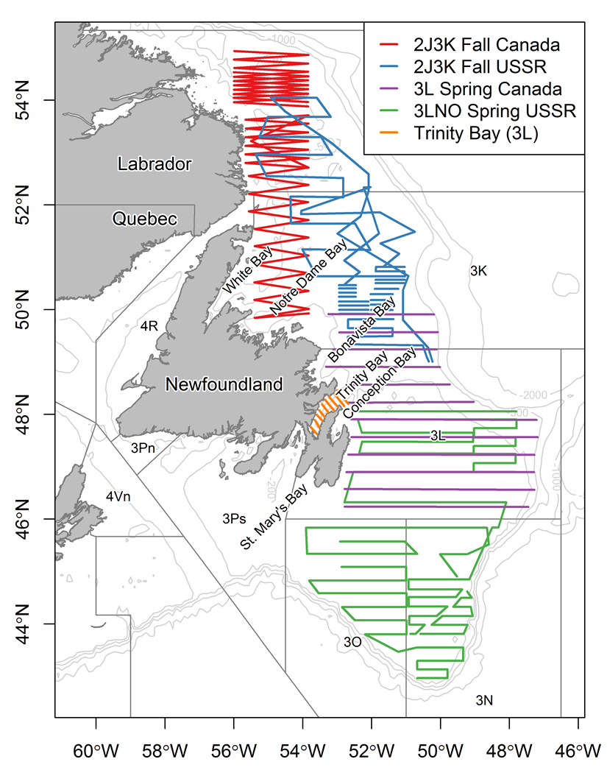

**Fig. 2**

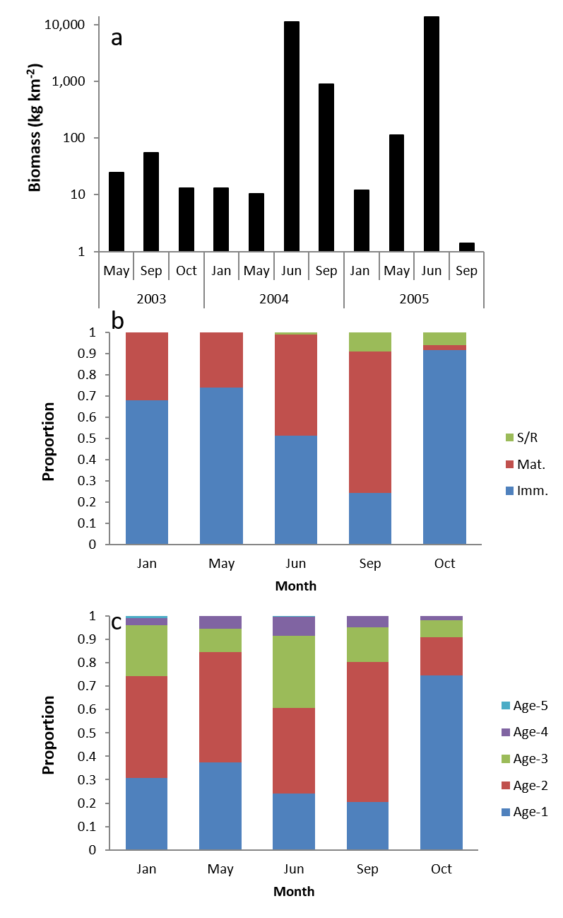

**Fig. 3**

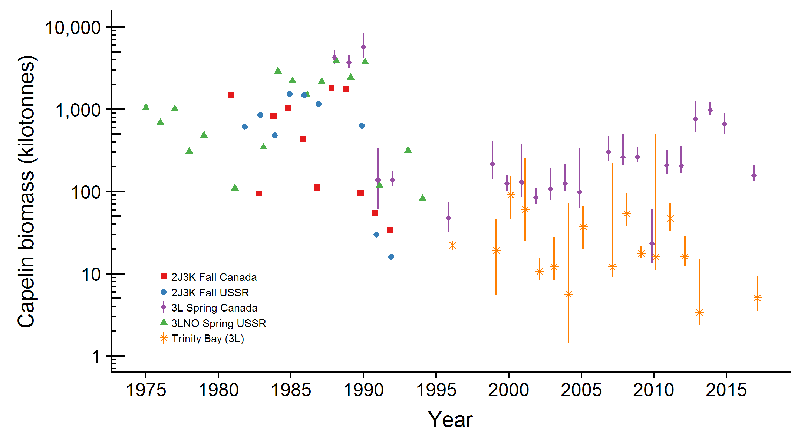

**Fig. 4**

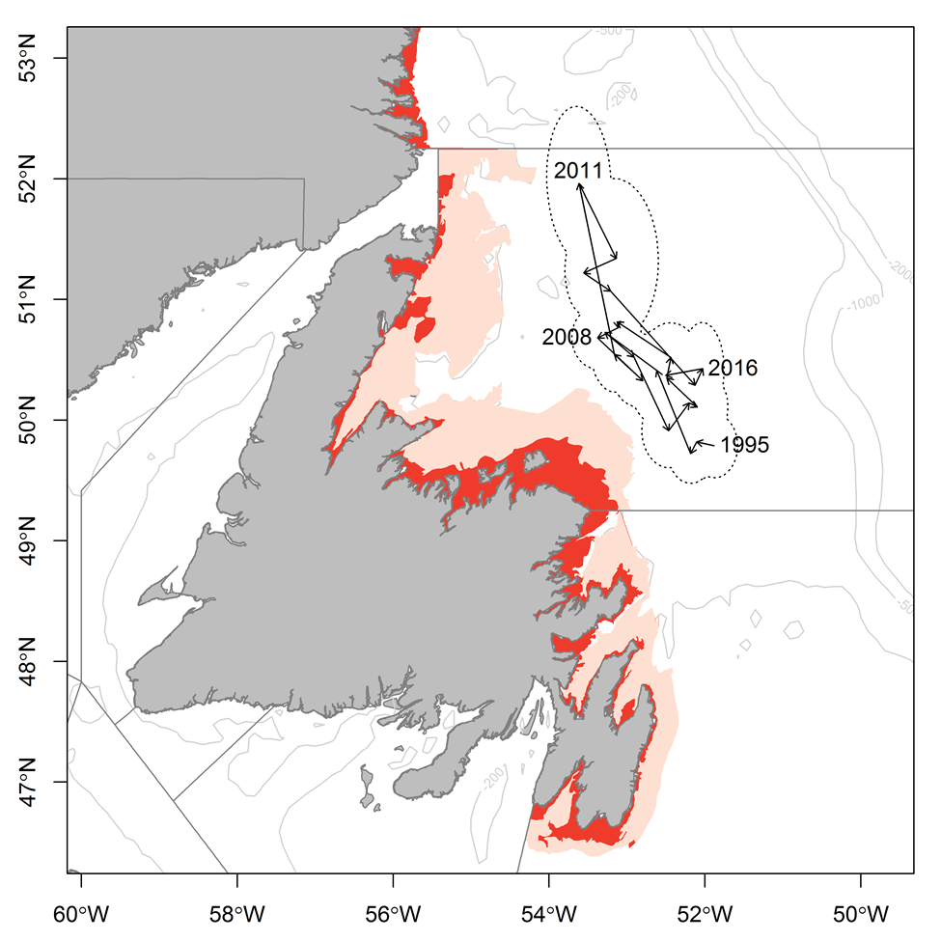

## Supplementary material

### Trinity Bay seasonal inshore acoustic surveys (2003-2005)

Inshore seasonal acoustic surveys (January, June, September 2003-05) in Trinity Bay, Canada were conducted from a 23 m inshore research vessel (CCGS Shamook) using a calibrated EK500 echo-sounder with a towed 38 kHz transducer. Surveys followed a fixed transect design and covered both the main portion of Trinity Bay as well as the four arms (Suppl. Fig 1). When acoustic targets were encountered, sampling was conducted using bottom and midwater trawls to target the portion of the water column where the acoustic signal occurred. Samples were obtained from most aggregations. Length, sex and maturity stage were recorded for all fish sampled and ages determined for two fish per sex per 0.5 cm interval.

Spatial patterns in age composition were similar to those patterns reported by Winters (1970) with older, larger capelin overwintering in the main portion of the bay while juvenile capelin were more prevalent in the inner arms. In all months except June, capelin were aggregated along the sides of the trench around 200 m depth, whereas in June capelin were present in the arms and in shallower water closer to shore at the bottom of the bay.

**Supplementary Figures**

Fig. S1 Inshore seasonal survey in Trinity Bay, Newfoundland, Canada (2003-2005) of acoustic transects (solid lines) and 100, 200 and 500 depth contours (dashed lines).

Fig. S1

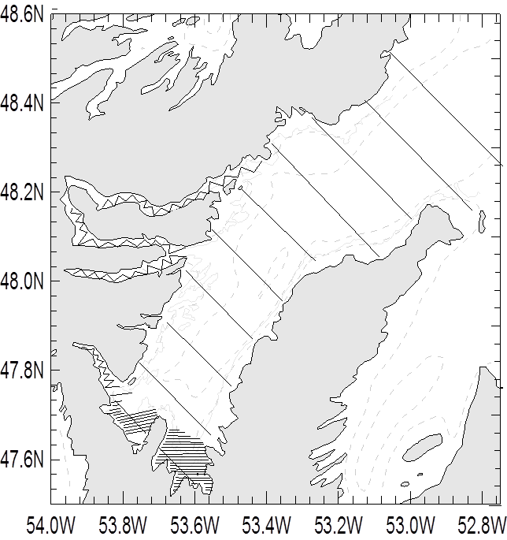

## References

Anderson JT, Dalley EL, O'Driscoll RL (2002) Juvenile capelin (*Mallotus villosus*) off Newfoundland and Labrador in the 1990s. ICES Journal of Marine Science 59:917-928

Anon (1998) Capelin in SA2 + Div. 3KL. Vol 98/63. Canadian Science Advisory Secretariat (CSAS) Research Document

Baillie SM, Jones IL (2004) Response of Atlantic Puffins to a Decline in Capelin Abundance at the Gannet Islands, Labrador. Waterbirds: The International Journal of Waterbird Biology 27:102-111

Bakanev VS (1992) Results from the acoustic capelin surveys in Div 3LNO and 2J+3KL in 1991. NAFO SCR Doc 92/1

Barange M, Bernal M, Cercole MC, Cubillos LA, Daskalov GM, Cunningham CL, de Oliveira JAA, Dickey-Collas M, Gaughan DJ, Hill K, Jacobson LD, Köster F, Massé J, Ñiquen M, Nishida H, Oozeki Y, Palomera I, Saccardo SA, Santojanni A, Serra R, Somarakis S, Stratoudakis Y, Uriarte A, van der Lingen CD, Yatsu A (2009) Current trends in the assessment and management of stocks. In: Checkley D, Alheit J, Oozeki Y, Roy C (eds), Vol 9. Cambridge University Press

Bennett SG, Burke CM, Hedd A, Montevecchi William A (2013) Comparison of capelin *Mallotus villosus* in the prey loads of common murres *Uria aalge* and northern gannets *Morus bassanus* foraging from the same breeding site in the northwest Atlantic. Marine Ornithology 41:179-182

Bourne C, Mowbray F, Squires B, Croft J (2015) An assessment framework and review of Newfoundland east and south coast Atlantic herring (*Clupea harengus*) stocks to the spring of 2013. Canadian Science Advisory Secretariat (CSAS) Research Document 2015/029

Bryant R, Jones IL (1999) Food Resource Use and Diet Overlap of Common and Thick-Billed Murres at the Gannet Islands, Labrador. Waterbirds: The International Journal of Waterbird Biology 22:392-400

Buren AD, Koen-Alonso M, Pepin P, Mowbray F, Nakashima BS, Stenson GB, Ollerhead N, Montevecchi WA (2014a) Bottom-up regulation of capelin, a keystone forage species. PLoS ONE 9:e87589

Buren AD, Koen-Alonso M, Stenson GB (2014b) The role of harp seals, fisheries and food availability in driving the dynamics of northern cod. Marine Ecology Progress Series 511:265-284

Burgess MG, Costello C, Fredston-Hermann A, Pinsky ML, Gaines SD, Tilman D, Polasky S (2017) Range contraction enables harvesting to extinction. Proceedings of the National Academy of Sciences 114:3945

Carscadden J, Nakashima BS, Miller DS (1994) An evaluation of trends in abundance of capelin (Mallotus villosus) from acoustics, aerial surveys and catch rates in NAFO Division 3L, 1982-89. Northw Atl Fish Sci 17:45-57

Carscadden JE, Frank KT, Leggett WC (2001) Ecosystem changes and the effects on capelin (*Mallotus villosus*), a major forage species. Canadian Journal of Fisheries and Aquatic Sciences 58:73-85

Carscadden JE, Gjøsæter H, Vilhjálmsson H (2013) A comparison of recent changes in distribution of capelin (*Mallotus villosus)* in the Barents Sea, around Iceland and in the Northwest Atlantic. Progress in Oceanography

Carscadden JE, Nakashima BS (1997) Abundance and changes in distribution, biology and behavior of capelin in response to cooler water of the 1990s. Forage fishes in marine ecosystems Proceedings of the International Symposium on the Role of Forage Fishes in Marine Ecosystems Alaska Sea Grant College Program Rep No AK-SG-97-01. University of Alaska Fairbanks, Fairbanks, Alaska

Chardine JW, Rail J-F, Wilhelm S (2013) Population dynamics of Northern Gannets in North America, 1984–2009. Journal of Field Ornithology 84:187-192

Chardine JW, Robertson GJ, Ryan PC, Turner B (2003) Abundance and distribution of common murres breeding at Funk Island, Newfoundland in 1972 and 2000. Canadian Wildlife Service Technical Report Series Atlantic Region:iv + 15

Chavez FP, Ryan J, Lluch-Cota SE, Ñiquen MC (2003) From anchovies to sardines and back: multidecadal change in the Pacific Ocean. Science 299:217-221

Colbourne E, Holden J, Craig J, Senciall D, Bailey W, Stead P, Fitzpatrick C (2014) Physical oceanographic conditions on the Newfoundland and Labrador Shelf during 2013. Canadian Atlantic Fisheries Scientific Advisory Committee Research Document 2014/094

Colbourne E, Holden J, Senciall D, Bailey W, Craig J, Snook S (2015) Physical oceanographic conditions on the Newfoundland and Labrador Shelf during 2014. Canadian Atlantic Fisheries Scientific Advisory Committee Research Document 2015/053

Colbourne E, Holden J, Senciall D, Bailey W, Snook S, Higdon J (2016) Physical oceanographic conditions on the Newfoundland and Labrador Shelf during 2015. Canadian Atlantic Fisheries Scientific Advisory Committee Research Document 2016/079

Dalley EL, Anderson JT, deYoung B (2002) Atmospheric forcing, larval drift, and recruitment of capelin ( Mallotus villosus ). ICES Journal of Marine Science 59:929-941

Davoren GK (2013) Distribution of marine predator hotspots explained by persistent areas of prey. Marine Biology 160:3043-3058

Davoren GK, Montevecchi WA (2003) Signals from seabirds indicate changing biology of capelin stocks. Marine Ecology Progress Series 258:253-261

Davoren GK, Penton P, Burke C, Montevecchi WA (2012) Water temperature and timing of capelin spawning determine seabird diets. ICES Journal of Marine Science 69:1234-1241

Dawe E, Koen-Alonso M, Chabot D, Stansbury D, Mullowney D (2012) Trophic interactions between key predatory fishes and crustaceans: comparison of two Northwest Atlantic systems during a period of ecosystem change. Marine Ecology Progress Series 469:233-248

deYoung B, Rose GA (1993) On recruitment and distribution of Atlantic cod (*Gadus morhua*) off Newfoundland. Canadian Journal of Fisheries and Aquatic Sciences 50:2729-2741

DFO (1994) Report on the status of pelagic fishes (capelin off Newfoundland and in the Gulf of St. Lawrence, and herring off the East, Southeast and South coasts off Newfoundland). DFO Atlantic Fisheries Stock Status Report 1994/3

DFO (2008) Assessment of capelin in SA2+Div. 3KL in 2008. DFO Canadian Science Advisory Secretariat Science Advisory Report 2008/054

DFO (2010) Assessment of Capelin in SA 2 + Div. 3KL in 2010. DFO Canadian Science Advisory Secretariat Science Advisory Report 2010/090

DFO (2013) Assessment of capelin in SA2 + Div. 3KL in 2013. DFO Canadian Science Advisory Secretariat Science Advisory Report 2013/11

DFO (2015) Assessment of capelin in Subarea 2 and Divisions 3KL in 2015. DFO Canadian Science Advisory Secretariat Science Advisory Report 2015/036

DFO (2018) Assessment of Capelin in SA2 and Divs. 3KL in 2017. DFO Canadian Science Advisory Secretariat Science Advisory Report 2018/030

Dragesund O, Toresen R, Østvedt OJ (2008) Norwegian spring-spawning herring: history of fsheries, biology and stock assessment. In: Nakken O (ed) Norwegian spring-spawning herring & Northeast Arctic cod 100 years of research and management. Tapir Academic Press

Drinkwater KF (1996) Atmospheric and oceanic variability in the Northwest Atlantic during the 1980s and early 1990s. Journal of Northwest Atlantic Fishery Science 18:77-97

Frank KT, Carscadden JE, Simon JE (1996) Recent excursions of capelin (*Mallotus villosus*) to the Scotian Shelf and Flemish Cap during anomalous hydrographic conditions. Canadian Journal of Fisheries and Aquatic Sciences 53:1473-1486

Frank KT, Leggett WC (1982) Coastal water mass replacement: its effect on zooplankton dynamics and the predator–prey complex associated with larval capelin (*Mallotus villosus*). Canadian Journal of Fisheries and Aquatic Sciences 39:991-1003

Frank KT, Petrie B, Boyce D, Leggett WC (2016) Anomalous ecosystem dynamics following the apparent collapse of a keystone forage species. Marine Ecology Progress Series 553:185-202

Gjøsæter H, Bogstad B, Tjelmeland S (2009) Ecosystem effects of the three capelin stock collapses in the Barents Sea. Marine Biology Research 5:40-53

Gomes MdC, Haedrich RL, Villagarcia MG (1995) Spatial and temporal changes in the groundfish assemblages on the north-east Newfoundland/Labrador Shelf, north-west Atlantic, 1978-1991. Fisheries Oceanography 4:85-101

Gulka J, Carvalho PC, Jenkins E, Johnson K, Maynard L, Davoren GK (2017) Dietary niche shifts of multiple marine predators under varying prey availability on the Northeast Newfoundland Coast. Frontiers in Marine Science 4

Hammill MO, Stenson GB, Doniol-Valcroze T, Mosnier A (2011) Northwest Atlantic harp seals population trends, 1952-2012. DFO Canadian Science Advisory Secretariat Research Document 2011/099

Hamre J (1994) Biodiversity and exploitation of the main fish stocks in the Norwegian - Barents Sea ecosystem. Biodiversity & Conservation 3:473-492

Haug T, Nilssen K (1995) Ecological implications of harp seals *Phoca groenlandica* invasions in northern Norway. In: Schytte Blix A, Walløe L, Ulltang Ø (eds) Whales, seals, fish and man. Elsevier Science

Head EJH, Pepin P (2010) Spatial and inter-decadal variability in plankton abundance and composition in the Northwest Atlantic (1958–2006). Journal of Plankton Research 32:1633-1648

Hop H, Gjøsæter H (2013) Polar cod (*Boreogadus saida*) and capelin (*Mallotus villosus*) as key species in marine food webs of the Arctic and the Barents Sea. Marine Biology Research 9:878-894

ICES (2017) Report of the North Western Working Group (NWWG). Copenhagen, Denmark

Jangaard PM (1974) The capelin (*Mallotus villosus*): biology, distribution, exploitation, utilization, and composition. Bulletin of the Fisheries Research Board of Canada 186:1-70

Jech JM, McQuinn IH (2016) Towards a balanced presentation and objective interpretation of acoustic and trawl survey data, with specific reference to the eastern Scotian Shelf. Canadian Journal of Fisheries and Aquatic Sciences 73:1914-1921

Koen-Alonso M, Fogarty M, Pepin P, Hyde K, Gamble R (2013) Ecosystem production potential in the Northwest Atlantic. Northwest Atlantic Fisheries Organisation Science Council Research Document 13/075

Koen-Alonso M, Pepin P, Mowbray F (2010) Exploring the role of environmental and anthropogenic drivers in the trajectories of core fish species of the Newfoundland-Labrador marine community.

Leggett WC, Frank KT, Carscadden JE (1984) Meteorological and hydrographic regulation of year-class strength in capelin (*Mallotus villosus*). Canadian Journal of Fisheries and Aquatic Sciences 41:1193-1201

Lilly GR (1987) Interactions between Atlantic cod (*Gadus morhua*) and capelin (*Mallotus villosus*) off Labrador and eastern Newfoundland: a review. Canadian Technical Report in Fisheries and Aquatic Sciences 1567:1-37

Lilly GR (1991) Interannual variability in predation by cod (*Gadus morhua*) on capelin (*Mallotus villosus*) and other prey off southern Labrador and northeastern Newfoundland. ICES Marine Science Symposia 193:133-146

Lilly GR (2005) Southern Labrador and eastern Newfoundland (NAFO Divisions 2J+3KL). In: Brander KM (ed) Spawning and life history information for North Atlantic cod stocks ICES Cooperative Research Report, No 274

Lilly GR, Brattey J, Cadigan NG, Healey BP, Murphy EF (2005) An assessment of the cod (*Gadus morhua*) stock in the NAFO Divisions 2J3KL in March 2005.

Lilly GR, Davis DJ (1993) Changes in the distribution of capelin in Divisions 2J, 3K and 3L in the autumns of recent years, as inferred from bottom-trawl by-catches and cod stomachs examinations. NAFO SCR Doc 93/54

Lilly GR, Hop H, Stansbury DE, Bishop CA (1994) Distribution and abundance of polar cod (*Boreogadus saida*) off southern Labrador and eastern Newfoundland. ICES CM 0:6

Lilly GR, Parsons DG, Kulka DW (2000) Was the increase in shrimp biomass on the northeast Newfoundland shelf a consequence of a release in predation pressure from cod? Journal of Northwest Atlantic Fishery Science 27:45-61

McQuinn IH (2009) Pelagic fish outburst or suprabenthic habitat occupation: legacy of the Atlantic cod (*Gadus morhua*) collapse in eastern Canada. Canadian Journal of Fisheries and Aquatic Sciences 66:2256-2262

Miller DS (1992) Observations and studies on SA2 + Div. 3K capelin in 1991. Canadian Atlantic Fisheries Scientific Advisory Committee Research Document 92/15

Miller DS (1993) Observations and studies on SA2 + Div. 3K capelin in 1992. Canadian Atlantic Fisheries Scientific Advisory Committee Research Document 93/10

Miller DS (1994) Results from an acoustic survey for capelin (*Mallotus villosus*) in NAFO Divisions 2J3KL in the autumn of 1993. Capelin in SA2 + Div 3KL DFO Atlantic Fisheries Research Document 94/18

Miller DS (1995) Results from an Acoustic Survey for Capelin (*Mallotus villosus*) in NAFO Divisions 2J3KL in the Autumn of 1994. Capelin in SA2 + Div 3KL DFO Atlantic Fisheries Research Document 95/70

Miller DS (1997) Results from an acoustic survey for capelin (*Mallotus villosus*) in NAFO Divisions 3KL in the spring of 1996. Capelin in SA2 + Div 3KL DFO Atlantic Fisheries Research Document 97/29

Miller DS, Lilly GR (1991) Observations and studies on SA2 + Div. 3K capelin in 1991. Canadian Atlantic Fisheries Scientific Advisory Committee Research Document 91/11

Montevecchi WA (2007) Binary dietary responses of northern gannets *Sula bassana* indicate changing food web and oceanographic conditions. Marine Ecology Progress Series 352:213-220

Montevecchi WA, Myers RA (1992) Monitoring fluctuations in pelagic fish availability with seabirds. Canadian Atlantic Fisheries Scientific Advisory Committee Research Document 92/94

Montevecchi WA, Myers RA (1997) Centurial and decadal oceanographic influences on changes in Northern Gannet populations and diets in the Northwest Atlantic: Implications for climate change. ICES Journal of Marine Science 54:608-614

Morgan MJ, Koen-Alonso M, Rideout RM, Buren AD, Maddock Parsons D (2017) Growth and condition in relation to the lack of recovery of northern cod. ICES Journal of Marine Science:fsx166-fsx166

Mowbray F (2002) Changes in the vertical distribution of capelin (*Mallotus villosus*) off Newfoundland. ICES Journal of Marine Science 59:942-949

Mowbray F (2012) Some results from spring acoustic surveys for capelin (*Mallotus villosus*) in NAFO Division 3L between 1982 and 2010. Canadian Science Advisory Secretariat (CSAS) Research Document 2012/143:1-34

Mowbray F (2014) Recent spring offshore acoustic survey results for capelin, *Mallotus villosus*, in NAFO Division 3L. DFO Canadian Science Advisory Secretariat Research Document 2013/040

Mullowney D, Maillet G, Dawe E, Rose G, Rowe S (2016) Spawning delays of northern capelin (*Mallotus villosus*) and recovery dynamics: A mismatch with ice-mediated spring bloom? Progress in Oceanography 141:144-152

Mullowney DRJ, Rose GA (2014) Is recovery of northern cod limited by poor feeding? The capelin hypothesis revisited. ICES Journal of Marine Science: Journal du Conseil

Munafò MR, Davey Smith G (2018) Robust research needs many lines of evidence. Nature 553:399-401

Murphy HM, Pepin P, Robert D (2018) Re-visiting the drivers of capelin recruitment in Newfoundland since 1991. Fisheries Research 200:1-10

NAFO (2014) Report of the 7th Meeting of the NAFO Scientific Council (SC) Working Group on Ecosystem Science and Assessment (WGESA). Northwest Atlantic Fisheries Organisation Science Council Studies Doc 14/023 Serial No N6410, NAFO Headquarters, Dartmouth, NS, Canada

Nakashima B (1996) The relationship between oceanographic conditions in the 1990s and changes in spawning behaviour, growth and early life history of capelin (M*allotus villosus)*. NAFO Sci Coun Studies 24:55-68

Nakashima BS (1997) Results of the 1996 aerial survey of capelin (*Mallotus villosus*) schools. Capelin in SA2 + Div 3KL DFO Atlantic Fisheries Research Document, 97/29

Nakashima BS, Mowbray F (2014) Capelin (*Mallotus villosus)* recruitment indices in NAFO Division 3KL. DFO Canadian Science Advisory Secretariat Research Document 2013/091

Nakashima BS, Wheeler JP (2002) Capelin (*Mallotus villosus*) spawning behaviour in Newfoundland waters - the interaction between beach and demersal spawning. ICES Journal of Marine Science 59:909-916

Neville V, Rose GA, Rowe S, Jamieson R, Piercey G (2018) Otolith chemistry and redistributions of northern cod: evidence of Smith Sound-Bonavista Corridor connectivity. Canadian Journal of Fisheries and Aquatic Sciences

Nilssen KT, Haug T, Øritsland T, Lindblom L, Kjellqwist SA (1998) Invasions of harp seals *Phoca groenlandica* Erxleben to coastal waters of nor way in 1995: Ecological and demographic implications. Sarsia 83:337-345

O'Driscoll RL, Rose GA (2001) In situ acoustic target strength of juvenile capelin. ICES Journal of Marine Science 58:342-345

Obradovich SG, Carruthers EH, Rose GA (2014) Bottom-up limits to Newfoundland capelin (Mallotus villosus) rebuilding: the euphausiid hypothesis. ICES Journal of Marine Science 71:775-783

Pálsson ÓK, Gislason A, Guðfinnsson HG, Gunnarsson B, Ólafsdóttir SR, Petursdottir H, Sveinbjörnsson S, Thorisson K, Valdimarsson H (2012) Ecosystem structure in the Iceland Sea and recent changes to the capelin (Mallotus villosus) population. ICES Journal of Marine Science 69:1242-1254

Pedersen EJ, Thompson PL, Ball RA, Fortin M-J, Gouhier TC, Link H, Moritz C, Nenzen H, Stanley RRE, Taranu ZE, Gonzalez A, Guichard F, Pepin P (2017) Signatures of the collapse and incipient recovery of an overexploited marine ecosystem. Royal Society Open Science 4

Pepin P, Colbourne E, Maillet G (2011) Seasonal patterns in zooplankton community structure on the Newfoundland and Labrador Shelf. Progress in Oceanography 91:273-285

Pepin P, Cuff A, Koen-Alonso M, Ollerhead N (2010) Preliminary Analysis for the Delineation of Marine Ecoregions on the NL Shelves. NAFO SCR Doc 10/72

Pepin P, Higdon J, Koen-Alonso M, Fogarty M, Ollerhead N (2014) Application of ecoregion analysis to the identification of Ecosystem Production Units (EPUs) in the NAFO Convention Area. NAFO SCR Doc 14/069

Pepin P, Koen-Alonso M, Higdon J, Ollerhead N (2012) Robustness in the delineation of ecoregions on the Newfoundland and Labrador continental shelf. NAFO SCR Doc 12/067

Pikitch EK, Boersma PD, Boyd IL, Conover DO, Cury PM, Essington TE, Heppell SS, Houde ED, Mangel M, Pauly D, Plagányi E, Sainsbury KJ, Steneck RS (2012) Little fish: big impact: managing a crucial link in ocean food webs. Lenfest Ocean Program, Washington, DC

Pikitch EK, Rountos KJ, Essington TE, Santora C, Pauly D, Watson R, Sumaila UR, Boersma PD, Boyd IL, Conover DO, Cury P, Heppell SS, Houde ED, Mangel M, Plagányi É, Sainsbury K, Steneck RS, Geers TM, Gownaris N, Munch SB (2014) The global contribution of forage fish to marine fisheries and ecosystems. Fish and Fisheries 15:43-64

Prince JD, Loneragan NR, Okey TA (2008) Contraction of the banana prawn (*Penaeus merguiensis*) fishery of Albatross Bay in the Gulf of Carpentaria, Australia. v. 59

Regular P, Montevecchi W, Hedd A, Robertson G, Wilhelm S (2013) Canadian fishery closures provide a large-scale test of the impact of gillnet bycatch on seabird populations. Biology Letters 9

Reid PC, Colebrook JM, Matthews JBL, Aiken J (2003) The Continuous Plankton Recorder: concepts and history, from Plankton Indicator to undulating recorders. Progress in Oceanography 58:117-173

Rice J (2002) Changes to the large marine ecosystem of the Newfoundland-Labrador shelf. In: Sherman K, Skjoldal HR (eds) Large marine ecosystems of the North Atlantic. Elsevier Science B.V.

Rose GA (1993) Cod spawning on a migration highway in the north-west Atlantic. Nature 366:458-461

Rose GA (2007) Cod: an ecological history of the North Atlantic fisheries. Breakwater Books, St John's, NL

Rose GA, deYoung B, Kulka DW, Goddard SV, Fletcher GL (2000) Distribution shifts and overfishing the northern cod (*Gadus morhua*): a view from the ocean. Canadian Journal of Fisheries and Aquatic Sciences 57:644-663

Rose GA, Kulka DW (1999) Hyperaggregation of fish and fisheries: how catch-per-unit-effort increased as the northern cod (*Gadus morhua*) declined. Canadian Journal of Fisheries and Aquatic Sciences 56:118-127

Rose GA, O'Driscoll RL (2002) Capelin are good for cod: can the northern stock rebuild without them? ICES Journal of Marine Science 59:1018-1026

Rose GA, Rowe S (2018) Does redistribution or local growth underpin rebuilding of Canada’s Northern cod? Canadian Journal of Fisheries and Aquatic Sciences:1-11

Schwartzlose RA, Alheit J, Bakun A, Baumgartner TR, Cloete R, Crawford RJM, Fletcher WJ, Green-Ruiz Y, Hagen E, Kawasaki T, Lluch-Belda D, Lluch-Cota SE, MacCall AD, Matsuura Y, Névarez-Martínez MO, Parrish RH, Roy C, Serra R, Shust KV, Ward MN, Zuzunaga JZ (1999) Worldwide large-scale fluctuations of sardine and anchovy populations. South African Journal of Marine Science 21:289-347

Skagseth Ø, Slotte A, Stenevik EK, Nash RDM (2015) Characteristics of the Norwegian Coastal Current during Years with High Recruitment of Norwegian Spring Spawning Herring (Clupea harengus L.). PLOS ONE 10:e0144117

Soutar A, Issacs JD (1969) History of fish populations inferred from fish scales in anaerobic sediments off California. CalCOFI Reports 13:63-70

Stenson GB (2012) Estimating consumption of prey by harp seals (*Pagophilus groenlandicus*) in NAFO Divisions 2J3KL. Canadian Science Advisory Secretariat (CSAS) Research Document 2012/156

Stenson GB, Buren AD, Koen-Alonso M (2016) The impact of changing climate and abundance on reproduction in an ice-dependent species, the Northwest Atlantic harp seal, *Pagophilus groenlandicus*. ICES Journal of Marine Science: Journal du Conseil 73:250-262

Stenson GB, Wakeham D, Buren AD, Koen-Alonso M (2014) Density-dependent and density-independent factors influencing reproductive rates in Northwest Atlantic harp seals, *Pagophilus groenlandicus*. DFO Canadian Science Advisory Secretariat Research Document 2014/058

Templeman W (1948) The life history of the caplin (*Mallotus villosus* O. F. Müller) in Newfoundland waters. Bulletin of the Newfoundland Government Laboratory 17:1-151

Thorson J, T., Pinsky M, L., Ward E, J., Gimenez O (2016) Model‐based inference for estimating shifts in species distribution, area occupied and centre of gravity. Methods in Ecology and Evolution 7:990-1002

Thorson JT, Barnett LAK (2017) Comparing estimates of abundance trends and distribution shifts using single- and multispecies models of fishes and biogenic habitat. ICES Journal of Marine Science 74:1311-1321

Toresen R, Østvedt OJ (2000) Variation in abundance of Norwegian spring-spawning herring (Clupea harengus, Clupeidae) throughout the 20th century and the influence of climatic fluctuations. Fish and Fisheries 1:231-256

Vilhjálmsson H (1994) The Icelandic capelin stock. Rit Fiskideildar 13:1-281

Wilberg MJ, Thorson JT, Linton BC, Berkson J (2009) Incorporating time-varying catchability into population dynamic stock assessment models. Reviews in Fisheries Science 18:7-24

Wilhelm SI, Mailhiot J, Arany J, Chardine JW, Robertson GJ, Ryan PC (2015) Update and trends of three important seabird populations in the western North Atlantic using a geographic information system approach. Marine Ornithology 43:211-222

Wilhelm SI, Robertson GJ, Ryan PC, Tobin SF, Elliot RD (2009) Re-evaluating the use of beached bird oiling rates to assess long-term trends in chronic oil pollution. Marine Pollution Bulletin 58:249-255

Winters GH (1970) Biological changes in coastal capelin from the over-wintering to the spawning condition. Journal of the Fisheries Research Board of Canada 27:2215-2224

Winters GH (1995) Interaction between timing, capelin distribution and biomass estimates from the Div. 2J3K capelin acoustic survey. Capelin in SA2 + Div 3KL. DFO Atlantic Fisheries Research Document 95/70

Winters GH, Carscadden JE (1978) Review of capelin ecology and estimation of surplus yield from predator dynamics. International Commission for the Northwest Atlantic Fisheries Research Bulletin 13:21-30

Winters GH, Wheeler JP (1985) Interaction Between Stock Area, Stock Abundance, and Catchability Coefficient. Canadian Journal of Fisheries and Aquatic Sciences 42:989-998

Worm B, Tittensor DP (2011) Range contraction in large pelagic predators. Proceedings of the National Academy of Sciences 108:11942